Presents
The
2018 Behavioral Health Peer Institute
“Arkansas ROCKS!”
RECOVERY~OPPORTUNITIES~CHOICES~KNOWLEDGE~SUPPORTS

HOSTED BY
PERSONAL EMPOWERMENT RECOVERY COALITION
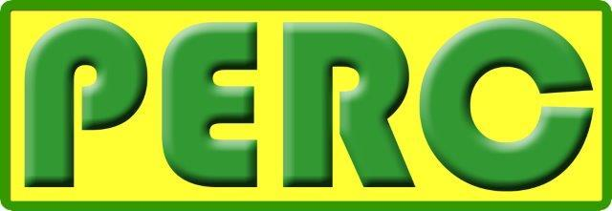

July 11-15, 2018

Little Rock Holiday Inn Airport Convention Center
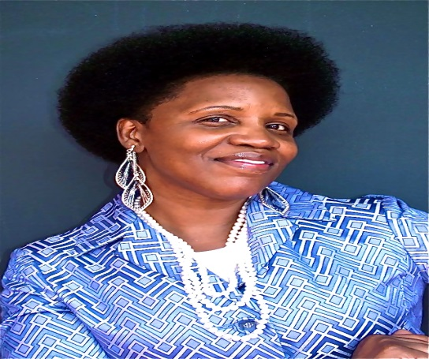
Keynote
Friday Morning
Sharon Denise Wise

Following over thirty years in and out of jails, institutions and hospitals, Sharon calls herself a Surviving Spirit” who’s life has been riddled with tragedy and those tragedies have led to laws and policies being changed all over the Country, and most of all, trauma informed Care training and practices being implemented.

She travels Nationally and Internationally sharing lessons learned and her personal story in hopes that lives will be transformed. She is a Trauma Expert and Lead Consultant whose clients include; Federal and Private Organizations, Department of Juvenile Justice, Women’s Trade Mission in England, Amsterdam and Germany training others in Leadership. Sharon is a Certified Whole Health and Peer Specialist, WRAP Facilitator and holds a Masters Degree in Human Services. She is a talented visual and performing Artist, with art hanging all over the world. She is recently collaborated with the faith-based community, with a vision to train more clergy in Trauma Informed Care.

Sharon is the recipient of the 2009 Joy Evans Award for Community Services, 2010 VOICE Award, 2011 Martin Luther Jr. Award for Community Services & 2011 Crisis Intervention Team Consumer Leadership Award, 2012 National Council Award for Contributions to the Arts, 2013 Community Service Award for Leadership and 2016 Charles Willis Award for her contributions to Peer leadership.
She has written several plays to include the award-winning hit play, “Meet Me On the Moon”, ”Dinner at Tuesday’s” and “I Wish”, She also wrote eleven self-published children’s books entitled “ S. Dillan Collection” about a dog who has bi-polar and a trauma history to educate children in her child friendly vernacular.
Agenda

Holiday Inn Airport Convention Center
July 11-15, 2018
Time | Activity | Wednesday July 11, 2018 | Location
 |  | Presenter/Course Description
8:30-9:00 | Registration
9:30-12:30 | WRAP Session 1 | Eddie Smith, Loretta Cochran, Jan Marshall | Lindberg
12:30-1:00 | Lunch | Lunch will be served in the Atrium | Atrium
1:05-4:30 | WRAP session 2 | Eddie Smith, Loretta Cochran, Jan Marshall
3:00-5:00 | Registration | Hotel check-in, conference registration, meet and greet
 |  | Thursday July 12, 2018
7:00-10:00 | Breakfast | Registration | Atrium
 |  | Presenter/Course Description
 |  | Early session
8:00-9:00 | TBA |  | Enterprise
8:30-9:30 |  | Networking/Vendors | Atrium
9:05-12:00 | Appalachian Model session 1 |  | Lindberg
 |  | Morning Sessions
9:35-10:35 | AR State Updates From DBHS | Dena Perry, | Reagan
10:45-11:45 | WRAP | Eddie Smith, Loretta Cochran, Jan Marshall | Enterprise
12:00-1:00 | Lunch |  | Kittyhawk North
12:35-6:00 | Appalachian Model session 2 |  | Lindberg
 |  | Afternoon Sessions
1:10-2:10 | Intro to Peer Support/Supervision | Larry Butler and Melissa Minor, LCSW | Reagan
 | TBA
2:30-3:30 | Advanced Psychiactric Directives | Nancy Draughon JD, | Kennedy
 | TBA
4:00-5:00 | Recovery 101 | Eddie Smith | Kennedy
 |  | Friday July 13, 2018
7:00-10:00 | Breakfast |  | Atrium
 |  | Early Session
8:00-9:00 | VA Crisis Intervention | ? | Enterprise
8:30-9:30 |  | Networking/Vendors | Atrium
9:05-12:00 | Appalachian Model session 3 |  | Lindberg
 |  | Morning Sessions1
9:35-10:35 |  |  | Reagan
 | Oral History of the Peer Movement:  A Movement in Motion | Bill Shumaker, Loretta Cochran, Lorraine Chism A Movement in Motion is a historical look back at the peer recovery movement in mental health and substance abuse. Bill, Lorraine and Loretta will weave the participants through parallel developments in the overall disability movement and specifically mental health and substance abuse histories. This road to recovery will include the fight for freedom and deinstitutionalization as well as the rise of the peer support community. | Kennedy
 | Advocacy TBA | Tennesse Mental health?
 | Spirituality & Recovery: An individual approach to healing and wholeness | Yvonne S. Cook, LCSW This presentation provides an individual approach to the inclusion of spirituality in recovery. The presenter focuses on the unique nature of spirituality from person to person and its manifestation in the beliefs and/or actions of individuals. Spirituality will be addressed through the lens of values, reframing regrets, forgiveness of self/others and maintaining a spirit of hopefulness. This presentation will enhance participant’s ability to incorporate spirituality into the helping process with less ambiguity. | Adams
 |  | Morning Sessions 2
10:45-11:45 | WRAP
 | Building Recovery of Individual Dreams & Goals through Education & Support | Lori Rash, LBSW, TCPRS -Tennessee Mental Health Consumer Association, (BRIDGES) is a self-help program that provides education and support to mental health consumers. It is available to adults who have a diagnosis of mental illness. There are two parts to the program: A set of courses on recovery taught by mental health consumers; and support groups facilitated by mental health consumers. This workshop will give participants a clear understanding of implementing BRIDGES within your agency/community. | Reagan
12:00-1:00 | Keynote Speaker | Sharon Wise | Kitty hawk  North
 |  | Afternoon Sessions1
1:10-2:10 | "The Connection Between My (SUD) and Mental Illness Diagnosis" | Larry Butler The importance of treating both diagnoses is essential to continuing moving forward in recovery. This session will discuss how I enrolled in treatment (4) times and experienced some success only to fail after a while. I’ll share some of my thoughts and fear of the experience. My return to the VA and my decision to address my mental illness diagnosis. | Reagan
1:10-2:10 | Appalachian Model session 4
 | Women do Recover | Doris Matthews The Women Do Recover Panel will be comprised of 4 women who are currently recovering from alcohol, drugs and mental health issues. We will each share our experience with substance abuse, what happened to get us sober, and how our lives have changed as a result of getting sober. We will also take questions from the audience about our journey in recovery. Doris Matthews, will facilitate as well as participate as a presenter. The other presenters in the panel are Debra Tyler, Zibilla Wolfe and Jackie Webster. | Adams
 | TBA |  | Kennedy
 |  | Afternoon Sessions 2
2:30-3:30 | Trauma Informed Care | Sharon Wise
 | Healthy Living | Lisa Stanley this session will explain the importance of healthy living on mental health and/or addictions recovery! | Adams
 | Call to Action: Advocacy in Arkansas | Loretta Cochran Self-empowerment or self-advocacy is the term for taking a more active role in one’s own care. Since individuals know their own situations the best, they can often be the best advocates for themselves. Self-advocacy can include any action, verbal or written, which is intended to outline and describe a particular problem an individual is encountering. Self-advocacy is intended to create the interest and action by another person to assist the person in resolving the specific problem. Thus, a person might be self-advocating to an individual (such as directly to a nurse or doctor), to an institution (such as a hospital, clinic, or substance abuse agency), or to a company or organized body (such as Medicaid, an insurance company or a state agency.) Individuals have progressively increased their proactive voice with the clinical, agency, and service community. This workshop will provide tools and resources to assist individuals in their ability to advocate for their own interests. | Kennedy
4:00-5:00 | Five Stages of Recovery | Eddie Smith
 |  | Saturday July 14, 2018
Time | Activity | Presenter/Course Description | Location
7:00-10:00 | Breakfast |  | Atrium
 | Early session |  | Kitty hawk  North
8:00-9:00 | Recovery Resources | Angie Lassiter
8:30-9:30 |  | Networking/ Vendors
9:05-12:00 | Appalachian Model session 5 |  | Lindberg
 |  | Morning Sessions 1
9:35-10:35 | The Pew vs. The Couch: How mental health providers can collaborate with faith communities to treat both mind and soul.” | Steve Sullivan, Mental illness affects not just our minds, but also our spirits. To treat others and ourselves holistically, means to treat both mind and soul. Both mental health providers and clergy seek to bring hope, peace, and abundant life to those in their care. But they are often suspicious of each other, don’t know each other personally, and don’t know where to begin to collaborate. This workshop will look at some of the barriers that have separated the pew and the couch for centuries, and look at what they share in common. Using lessons learned from the VA/Clergy Partnership for Veterans, we will also discuss some practical ways to build trust and collaborate so that we, our clients, and those in our faith community can thrive spiritually and mentally.
 | TBA
12:00-1:00 | Keynote Speaker | Anthony Fox, Director of TMHCA | Kitty hawk  North
1:10-2:10 | Wellness Recovery Action Plan | Jennifer Jones, LMSW - Tennessee Mental Health Consumers Association WRAP®, is a system for monitoring, reducing, and eliminating uncomfortable or dangerous physical and emotional difficulties. It was developed by Dr. Mary Ellen Copeland 18 years ago and has since been presented internationally. During the workshop we will explore the 5 Key Concepts that support the plan and cover all of the parts that make up a WRAP® with examples. | Adams
1:10-6:30 | Appalachian Model session 6
 |  | Sunday July 15, 2018
7:00-10:00 | Breakfast |  | Atrium
 |  | Early Session
8:00-9:00 | Meditation and Recovery | Lisa Kessler This presentation will discuss the roots of Buddhism, how it came to be practiced in the US and how it is used today to address modern difficulties. After discussion the class will do a brief group meditation and discuss their experience after the meditation is completed.
8:30-9:30 |  | Networking/Vendors | Atrium
9:05-12:00 | Appalachian Model session 7
 |  | Morning Sessions
9:35-10:35 | TBA |  | Reagan
 | Peer Panel | Eddie Smith, Larry Butler this session will enlighten participants with information on why peer support is an important part for recovery of mental health challenges and substance abuse. A video will be introduced by Pat Brannin, DBHS, to greater emphasize peer support. | Kennedy
12:00-1:00 | Lunch |  | Atrium
12:35-6:00 | Appalachian Model session 8 |  | Lindberg

