Vision Statement
We are an ennobling statewide organization run by persons with lived experience of recovery that has global impact. We promote hope, respect, and appreciation of diversity through transformation and mutual support, creating a collaborative community

Mission Statement
The Personal Empowerment Recovery Coalition is a state-wide, peer-run organization that exists to: Advocate for the empowerment of persons with lived experience of behavioral health challenges; Promote transformation of the behavioral health care system, to be compassionate, trauma informed, person-centered and strength based; Educate policy makers, behavioral health consumers and the general public in Arkansas to eliminate stigma and demonstrate that recovery is possible.

.
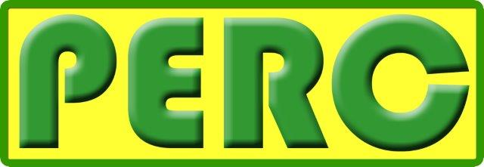

Personal Empowerment Recovery Coalition
Application for Board Membership


Name: ______________________________________ Date: ______________

Address: ________________________________________________________

City: _________________________________ Zip Code: __________________

Phone: ________________________ E-Mail: __________________________

Please summarize the reasons you are interested in becoming a Board Member in PERC.
_______________________________________________________________

_______________________________________________________________
_______________________________________________________________

_______________________________________________________________

_______________________________________________________________

_______________________________________________________________

Please tell us about your experience in matters of mental health, substance abuse and recovery.

_______________________________________________________________

_______________________________________________________________
_______________________________________________________________

_______________________________________________________________

_______________________________________________________________

_______________________________________________________________

Please describe how you see your own recovery as it connects to your role in advocacy, educating and building community.
_______________________________________________________________

_______________________________________________________________
_______________________________________________________________

_______________________________________________________________

_______________________________________________________________

_______________________________________________________________

Please tell us about your experience working in groups. We are especially interested in any experience you may have in advocacy, education, shared support and collaboration (for yourself, a family member, friend, peer or other).
_______________________________________________________________

_______________________________________________________________
_______________________________________________________________

_______________________________________________________________

_______________________________________________________________
Please summarize how you see your role in contributing as a Board Member.
_______________________________________________________________

_______________________________________________________________
_______________________________________________________________

_______________________________________________________________

_______________________________________________________________

_______________________________________________________________

What skills or experience do you possess that would make you a good Board Member?
_______________________________________________________________

_______________________________________________________________
_______________________________________________________________

_______________________________________________________________

_______________________________________________________________

_______________________________________________________________

Please initial the following items to indicate understanding:

I am willing to begin attending the next face to face meeting following this application and acceptance process and make a three year commitment as a PERC Board Member. I understand that my first year will be a probationary period where the relationship may be terminated by either party at any time by a two-thirds majority vote by the remaining board members or at the request of the probationary board member.

I understand that this is a volunteer position (though travel compensation will be provided), but that my role and regular attendance is the most important aspect of my commitment as a PERC Board Member.

I am able to commit to attending regular, monthly teleconference calls.

I understand that my role will include representing my voice as well as the voice of my local community while still keeping the ‘big picture’ of the whole PERC community in mind.

It is the policy of this organization to provide equal opportunities without regard to race, color, religion (non-religion), national origin, gender, sexual orientation, age, or disability.

Thank you for completing this application form and for your interest in working with us!

derstand

